

Deccan Education Society's

NAVINCHANDRA MEHTA INSTITUTE OF TECHNOLOGY AND DEVELOPMENT

# NAAC Accredited “B++”

**FOOD DELIVERY APPLICATION**

SUBMITTED BY

**Tanmay Pednekar (C22098)**

**Pranali Raul (C22104)**

Mentor: Prof. **Swapnali Mahadik**

Director: Dr. Samadhan Khamkar

**ACADEMIC YEAR 2022-2023**

Submitted to University of Mumbai

in partial fulfillment of the requirements for qualifying

MASTER OF COMPUTER APPLICATION

Examination

## **Deccan Education Society’s**

NAVINCHANDRA MEHTA INSTITUTE OF TECHNOLOGY AND DEVELOPMENT

**Deccan Education Society’s**

**Navinchandra Mehta Institute of Technology & Development**

C E R T I F I C A T E

This is to certify that Mr. Tanmay Pednekar & Ms. Pranali Raul of M.C.A. Semester I with Roll No(s). C22098, C22104 has completed Mini Project under my supervision in this college during the year 2022-2023**.**

|  |  |  |  |  |  |
| --- | --- | --- | --- | --- | --- |
| CO | R1  Frequency of reporting and overall performance | R2  Choice of Open Source Innovative Tool and Case Study or Problem Statement | R3  Function as an effective collaborator, member or leader in a team | R4  Quality of implementation for technical solution | R5  Complilation of project report and presentation |
| CO1 |  |  |  |  |  |
| CO2 |  |  |  |  |  |
| CO3 |  |  |  |  |  |
| CO4 |  |  |  |  |  |

Mentor Head of

Department

(MCA Department)

**ACKNOWLEDGEMENT**

Achievement is finding out what you would be doing rather than what you have to do. It

is not until you undertake such a project that you realize how much effort and hard

work it really is, what are your capabilities and how well you can present yourself or

other things. It tells us how much we rely on the efforts and goodwill of others. It gives

me immense pleasure to present this report towards the fulfilment of my project.

It has been rightly said that we are built on the shoulder of others. For everything I have

achieved, the credit goes to all those who had helped me to complete this project

successfully.

We take this opportunity to express my profound gratitude to management of **Deccan**

**Education Society's Navinchandra Mehta Institute Of Technology & Development**

for giving me thisopportunity to accomplish this project work.

We are very much thankful to **Dr. Samadhan Khamkar** - Director of DES for their kind

co-operation in the completion of my project.

A special vote of thanks to our faculty **Prof. Rasika Mallya** who is our HOD & also our

project guide **Prof. Swapnali Mahadik** for their sincere, useful and

encouraging throughout the project span, without them we couldn’t start and complete

project on time.

**Abstract**

In today's fast-paced world, the demand for convenience and efficiency in accessing daily necessities has never been higher. Among these, food delivery stands out as a domain that has seen significant growth in recent years. The Food Delivery Application System Project aims to address this growing demand by offering a comprehensive solution for both consumers and food establishments.

Objectives:

1. To provide a platform where users can easily browse, select, and order food from their favorite restaurants.

2. To offer a streamlined system for restaurants to receive and manage orders efficiently.

3. To incorporate a real-time tracking system, allowing customers to track the status and location of their orders.

Key Features:

1. User Profiles: Allows users to create and manage their profiles, save favorite restaurants, and maintain a history of past orders.

2. Search and Browse Functionality: Users can search for specific cuisines, dishes, or restaurants. Additionally, filters like rating, cost, and distance can be applied.

3. Order Management: Enables customers to customize their orders, add special instructions, and view a detailed breakdown of the total cost.

4. Real-time Tracking: Once an order is placed, users can track their delivery in real time, with constant updates on the estimated time of arrival.

5. Feedback and Rating System: After receiving their orders, customers can rate the restaurant and the delivery service, aiding others in making informed decisions.

6. Restaurant Dashboard: An intuitive interface for restaurants to manage incoming orders, update menu items, and track their overall performance.

7. Integrated Payment System: Supports multiple payment methods like credit/debit cards, mobile wallets, and cash on delivery.

8. Notifications and Alerts: Users receive timely updates about order confirmations, dispatch details, and promotional offers.

In conclusion, the Food Delivery Application System Project offers a holistic approach to revolutionize the food delivery sector. By addressing the needs of all stakeholders – consumers, restaurants, and delivery personnel – this platform is poised to make a lasting impact in the domain of on-demand food delivery services.

**INDEX**

|  |  |  |  |
| --- | --- | --- | --- |
| **Chapter** |  | **Contents** | **Page No.** |
| **I** |  | **Introduction** | 7 |
|  |  |  |  |
| **II** |  | **System Design** | 8-11 |
|  | 2.1 | Exising System |  |
|  | 2.2 | Proposed System |  |
|  | 2.3 | Software Requirements |  |
|  | 2.4 | Hardware Requirements |  |
|  |  |  |  |
| **III** |  | **Overall Description of the proposed system** | 12-14 |
|  | 3.1 | Module Description |  |
|  | 3.2 | System Features |  |
|  | 3.3 | Gantt Chart |  |
|  |  |  |  |
| **IV** |  | **Design** | 15-26 |
|  | 4.1 | UML Diagram |  |
|  | 4.1.1 | UseCase Diagram |  |
|  | 4.1.2 | Sequence Diagram |  |
|  | 4.1.3 | Table Design |  |
|  | 4.1.4 | Data Flow Diagram |  |
|  | 4.1.5 | Flow Diagram |  |
|  | 4.1.6 | Architecture |  |
|  | 4.1.7 | ER Diagram |  |
|  |  |  |  |
| **V** |  | **Output Screenshots** | 27-30 |
|  |  |  |  |
| **VI** |  | **Implementation Details** | 31-36 |
|  | 6.1 | Introduction to HTML Framework |  |
|  | 6.2 | Cascading Style Sheets (CSS) |  |
|  | 6.3 | MySQL Server |  |
|  | 6.4 | Node JS |  |
|  | 6.5 | AngularJS |  |
|  |  |  |  |
| **VII** |  | **System Study** | 37 |
|  |  |  |  |
| **VIII** |  | **Technical Feasiblity** | 38-39 |
|  |  |  |  |
| **IX** |  | **System Testing** | 40-47 |
|  |  | Test Cases |  |
|  |  |  |  |
| **X** |  | **Conclusions** | 48 |
|  |  |  |  |
| **XI** |  | **References** | 49 |

**Introduction**

In the digital age, where convenience is often equated with technology, the way we access and consume food has undergone a significant transformation. Gone are the days when dining out or self-preparation were the only options available. Today, with just a few taps on a smartphone, a wide range of delicacies from multiple restaurants can be delivered right to our doorsteps. The Food Delivery Application Project is a response to this contemporary shift in consumption patterns, aiming to make the process of ordering food online even more seamless and user-friendly.

**Context and Need for the Project :**

The urban lifestyle, characterized by hectic schedules, increased disposable incomes, and the ever-growing need for convenience, has paved the way for on-demand services. Among these, food delivery services have emerged as one of the most sought-after solutions. According to recent statistics, the global online food delivery market size was valued at approximately USD 150 billion in 2021 and is projected to grow exponentially in the coming years.

However, despite its popularity, many challenges plague the industry. These range from subpar user experiences, mismanagement of orders, to lack of real-time tracking systems. The Food Delivery Application Project aims to bridge these gaps and provide an enhanced experience for all stakeholders involved.

**Project Overview :**

Our application endeavors to simplify the process of online food ordering for consumers, while also streamlining the order management system for restaurants. It integrates the latest technological advancements, including real-time GPS tracking, AI-driven recommendations, and an intuitive user interface. Moreover, the application emphasizes the security of user data and transactions, ensuring trust and reliability.

**Scope of the Project :**

This project covers:

1. Consumer Perspective: Easy browsing, personalized recommendations, order placement, real-time tracking, and feedback system.

2. Restaurant Perspective: Efficient order management, menu updates, customer analytics, and performance metrics.

3. Delivery Personnel Perspective: Transparent job listings, optimized route suggestions, and a feedback mechanism.

4. Admin and Backend: Robust server-side management, data analytics, security protocols, and marketing tools.

**System Design**

**\*\*Existing System:\*\***

1. **Limited Online Presence:** Traditional restaurants might rely heavily on physical walk-ins and phone orders.

2. **Manual Tracking:** Customers might have limited insight into the status of their order or its delivery.

3. **Fixed Menu:** Changes to the menu may require manual updates, making it difficult to offer real-time discounts or specials.

4. **Cash Transactions:** Primarily dependent on cash-on-delivery with limited online payment options.

5. **Inefficient Delivery Management:** Delivery routes are decided by drivers without optimization tools, leading to slower delivery times.

**\*\*Proposed System:\*\***

1. **Digital Platform:** An all-in-one platform that provides restaurants with online visibility, allowing them to reach a broader customer base.

2. **Real-time Tracking:** Customers can track their orders in real-time from preparation to delivery.

3. **Dynamic Menu Updates:** Restaurants can easily update menus, add discounts, and introduce new items.

4. **Multiple Payment Gateways:** Integration of various online payment methods, reducing dependency on cash.

5. **Optimized Delivery Management:** AI-driven delivery route optimization for faster and more efficient deliveries.

**\*\*Software Requirements:\*\***

1. **Operating System:** Cross-platform compatibility, such as Android (for Android devices) and iOS (for Apple devices).

2. **Database Management System:** PostgreSQL or MySQL to store user profiles, restaurant data, order details, etc.

3. **Server:** Cloud platforms like AWS, Google Cloud, or Azure for hosting services.

4. **Front-end Development:** React Native or Flutter for cross-platform app development.

5. **Back-end Development:** Node.js or Django for server-side scripting.

6. **Payment Gateway Integration:** APIs for platforms like Stripe, PayPal, or regional payment services.

7. **GPS Integration:** Google Maps or similar services for location tracking and route optimization.

**\*\*Hardware Requirements:\*\***

1. **Server:** High-performance server for hosting the application, with sufficient storage and backup facilities.

2. **Mobile Device:** A smartphone (Android/iOS) for app testing and deployment. It should have adequate RAM and processing speed for smooth app functioning.

3. **POS Integration (for restaurants):** Hardware that supports integration with the digital ordering system, for real-time updates on orders.

4. **Network:** Stable and high-speed internet connection for seamless connectivity between the server, restaurants, delivery personnel, and customers.

5. **GPS Hardware:** For delivery personnel, a device that supports real-time location tracking, usually a smartphone with GPS capabilities.

This represents a generalized overview of requirements and systems. Specifics can vary based on region, scale of the application, and other business-related factors.

**\*\*Overall Description of the Proposed System:\*\***

The proposed Food Delivery Application system aims to revolutionize the food ordering experience by providing a user-friendly platform that connects customers, restaurants, and delivery personnel. By digitalizing and optimizing the entire ordering process, it ensures timely deliveries, real-time updates, and enhanced user satisfaction.

**\*\*Module Description:\*\***

1. **User Module:**

- **Profile Management:** Allows users to sign up, log in, and manage their profiles.

- **Order Management:** Enables users to place, modify, track, and review past orders.

- **Payment Management:** Allows users to add multiple payment methods and view transaction history.

2. **Restaurant Module:**

- **Profile Management:** Restaurants can create, manage, and update their profiles, showcasing their offerings.

- **Menu Management:** Update menu items, prices, and dish details.

- **Order Management:** View incoming orders, update order status (preparing, ready for pickup, etc.), and manage past order history.

3. **Delivery Personnel Module:**

- **Profile Management:** Allows delivery persons to sign up, log in, and manage their details.

- **Delivery Management:** View order pick-up and drop-off details, update delivery status, and optimize routes.

- **Earnings Management:** Track earnings, tips, and review payment history.

4. **Admin Module:**

- **User Management:** Oversee and manage user, restaurant, and delivery personnel profiles.

- **Analytics:** Access to data analytics for order trends, popular restaurants, user feedback, etc.

- **Issue Resolution:** Handle complaints, disputes, and provide solutions.

**\*\*System Features:\*\***

**1. User Management:**

- **Sign-Up/Registration:** Allow users to register using email, phone number, or social media profiles.

- **Login:** Secure user login with features like two-factor authentication for enhanced security.

- **Profile Management:** Users can update their personal details, profile picture, addresses, and other preferences.

**2. Browsing & Search:**

- **Restaurant Listings:** Display available restaurants based on location, preferences, or user's search terms.

- **Advanced Search:** Allow users to search based on cuisine, dish names, or restaurant names.

- **Filters:** Users can sort and filter restaurant listings based on ratings, distance, offers, or delivery time.

**3. Menu & Ordering:**

- **Detailed Menu:** Each restaurant displays a detailed menu with pictures, dish descriptions, and prices.

- **Customizable Orders:** Options for adding extras, toppings, or specific instructions for each dish.

- **Cart Management:** Users can add multiple dishes from one or more restaurants, view their cart, and modify orders before finalizing.

- **Order Placement:** Seamless process to confirm the order and move to payment.

**4. Payment System:**

- **Multiple Payment Methods:** Integration of various payment gateways including credit/debit cards, mobile wallets, net banking, etc.

- **Secure Transactions:** Encryption and other security measures to ensure safe transactions.

- **Promo Codes & Discounts:** Users can apply promotional codes for discounts on their orders.

**5. Order Tracking:**

- **Real-time Tracking:** Users can track the delivery person's location in real-time once the order is out for delivery.

- **Status Updates:** Notifications or updates for various stages like order confirmed, preparing, dispatched, etc.

**6. Feedback & Ratings:**

- **Ratings:** After delivery, users can rate the restaurant and the delivery experience.

- **Reviews:** Users can leave feedback on specific dishes or the overall restaurant experience.

**7. Restaurant Management (For restaurant owners):**

- **Dashboard:** Real-time view of incoming orders, completed orders, and earnings.

- **Menu Management:** Update dishes, prices, and descriptions as needed.

- **Analytics:** Insights into popular dishes, peak order times, and customer feedback to enhance services.

**8. Admin & Backend Management:**

- **User Management:** Admin can oversee user, restaurant, and delivery personnel accounts.

- **Content Moderation:** Monitor and manage reviews, feedback, and any inappropriate content.

- **Data Analytics & Reporting:** Access detailed insights on app usage, order trends, revenue, etc.

**\*\*Gantt Chart:\*\***

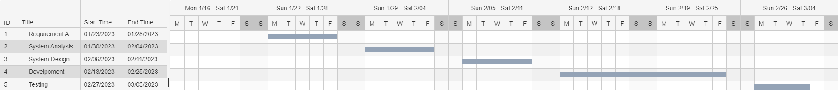

**Requirement Analysis**

|  |  |  |  |
| --- | --- | --- | --- |
| **Name** | **Start Date** | **End Date** | **Duration** |
| Preliminary Investigation | Jan 23, 2023 | Jan 23, 2023 | 1 |
| Project Topic Discussion | Jan 24, 2023 | Jan 24, 2023 | 1 |
| Current System Description | Jan 25, 2023 | Jan 25, 2023 | 1 |
| Proposed System Description | Jan 26, 2026 | Jan 26, 2023 | 1 |
| Feasibility Study | Jan 27, 2027 | Jan 27, 2023 | 1 |

**System Anaysis**

|  |  |  |  |
| --- | --- | --- | --- |
| **Name** | **Start Date** | **End Date** | **Duration** |
| ER Diagram | Jan 30, 2023 | Jan 30, 2023 | 1 |
| Class Diagram | Jan 31, 2023 | Jan 31, 2023 | 1 |
| Activity Diagram | Feb 01, 2023 | Feb 01, 2023 | 1 |
| Sequence Diagram | Feb 02, 2026 | Feb 02, 2023 | 1 |
| Use Case Diagram | Feb 03, 2027 | Feb 03, 2023 | 1 |

**System Design**

|  |  |  |  |
| --- | --- | --- | --- |
| **Name** | **Start Date** | **End Date** | **Duration** |
| Component Diagram | Feb 06, 2023 | Feb 07, 2023 | 2 |
| Deployment Diagram | Feb 08, 2023 | Feb 09, 2023 | 2 |
| Table Diagram | Feb 10, 2023 | Feb 10, 2023 | 1 |

**Development**

|  |  |  |  |
| --- | --- | --- | --- |
| **Name** | **Start Date** | **End Date** | **Duration** |
| System Coding | Feb 13, 2023 | Feb 24, 2023 | 10 |

**Testing**

|  |  |  |  |
| --- | --- | --- | --- |
| **Name** | **Start Date** | **End Date** | **Duration** |
| Component Diagram | Feb 27, 2023 | Mar 03, 2023 | 5 |

**Design**

**Use Case Diagram**

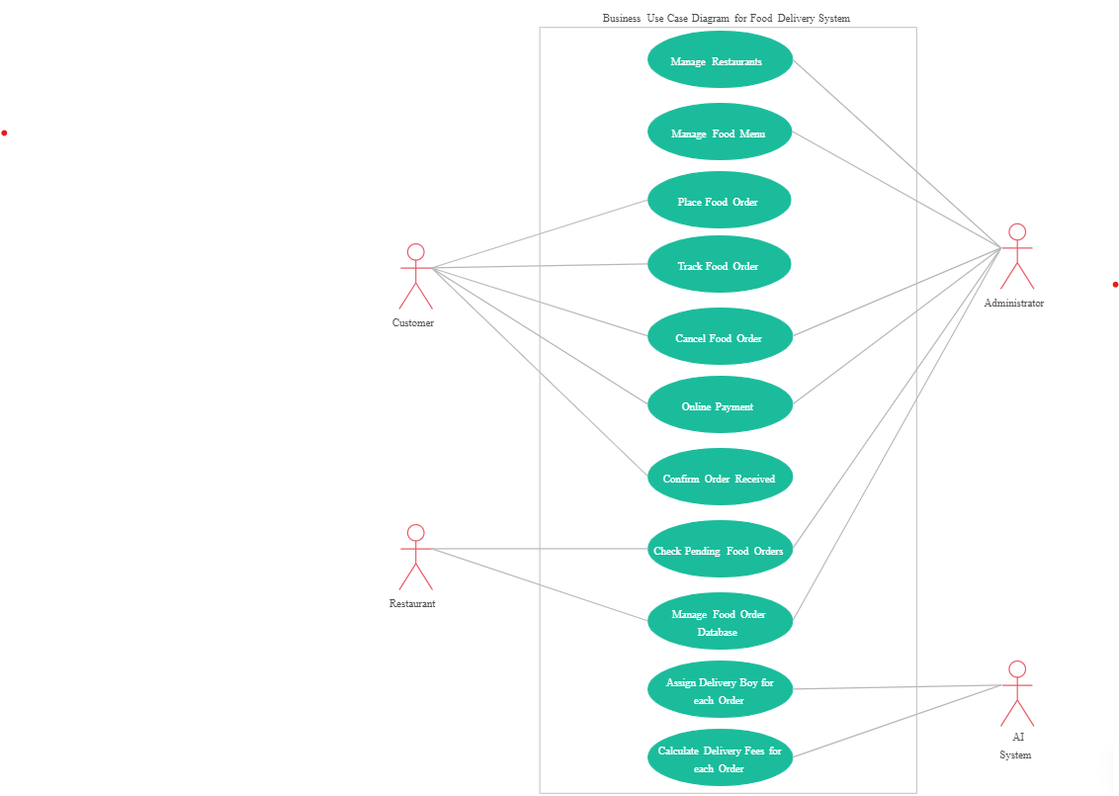

**Sequence Diagram**

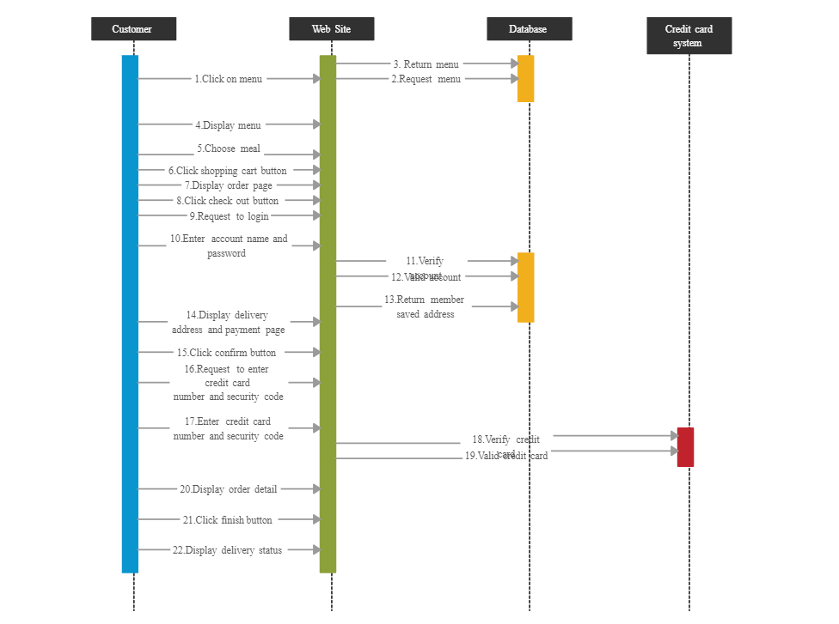

**Table Design**

**Customer**

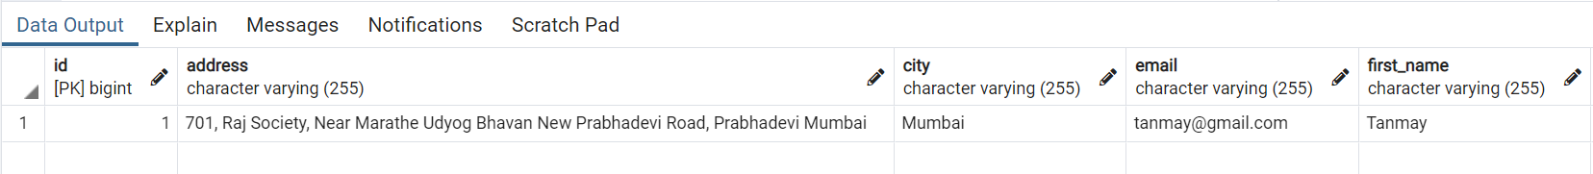

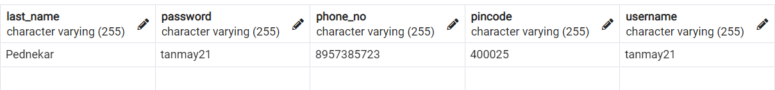

**Restaurant**

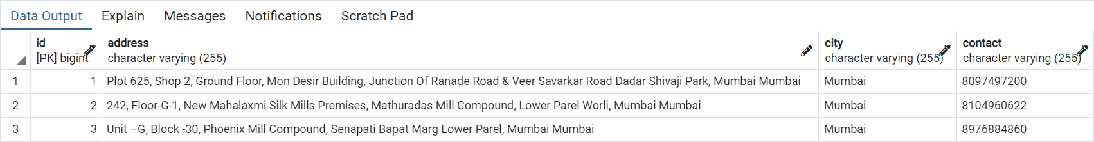



**Delivery Boy**

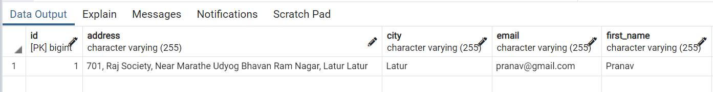

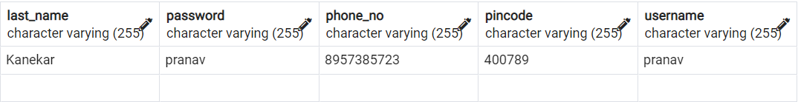

**Cart**



**Order**

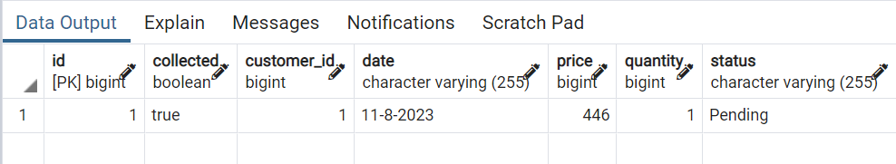

**Order Details**

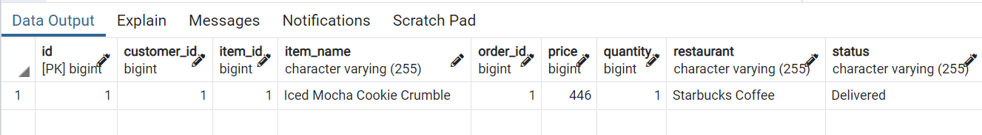

**Ratings**

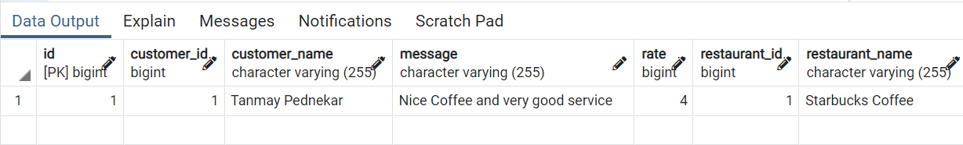

**Food Item**

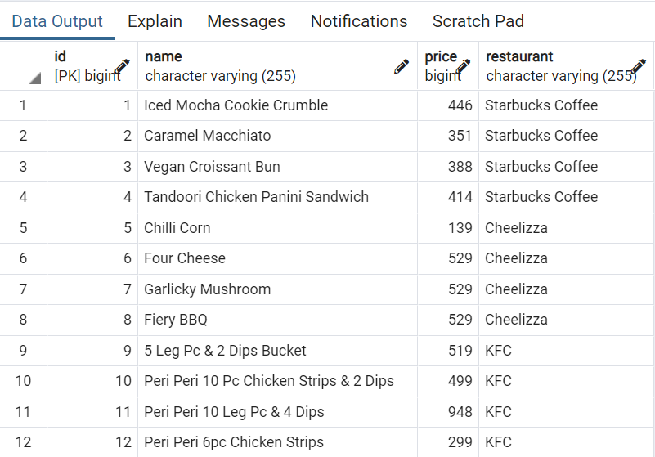

**Payment**

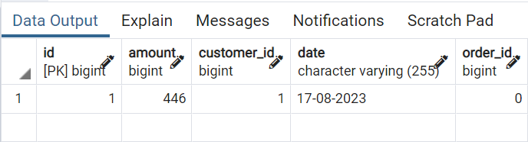

**ER – Diagram**

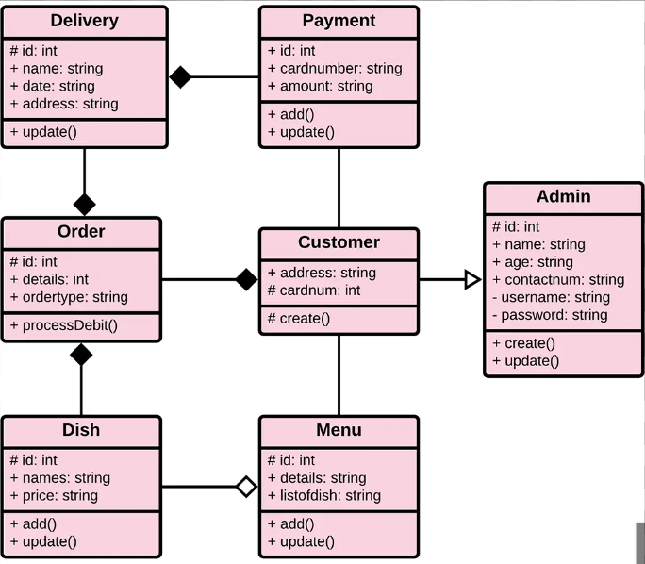

**Output Screenshots**

**Login :**

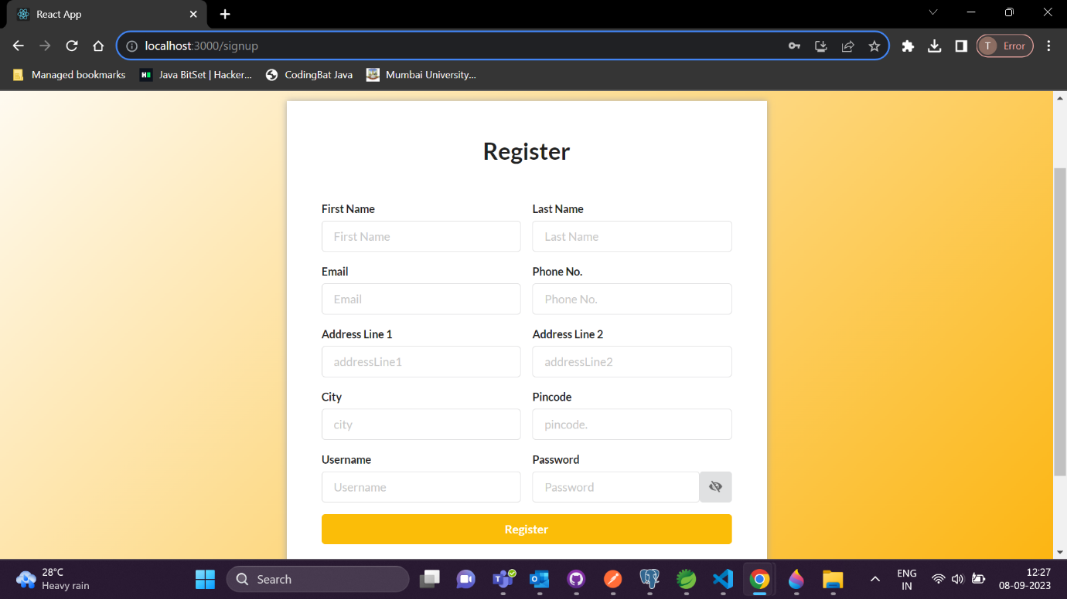

**Sign up :**

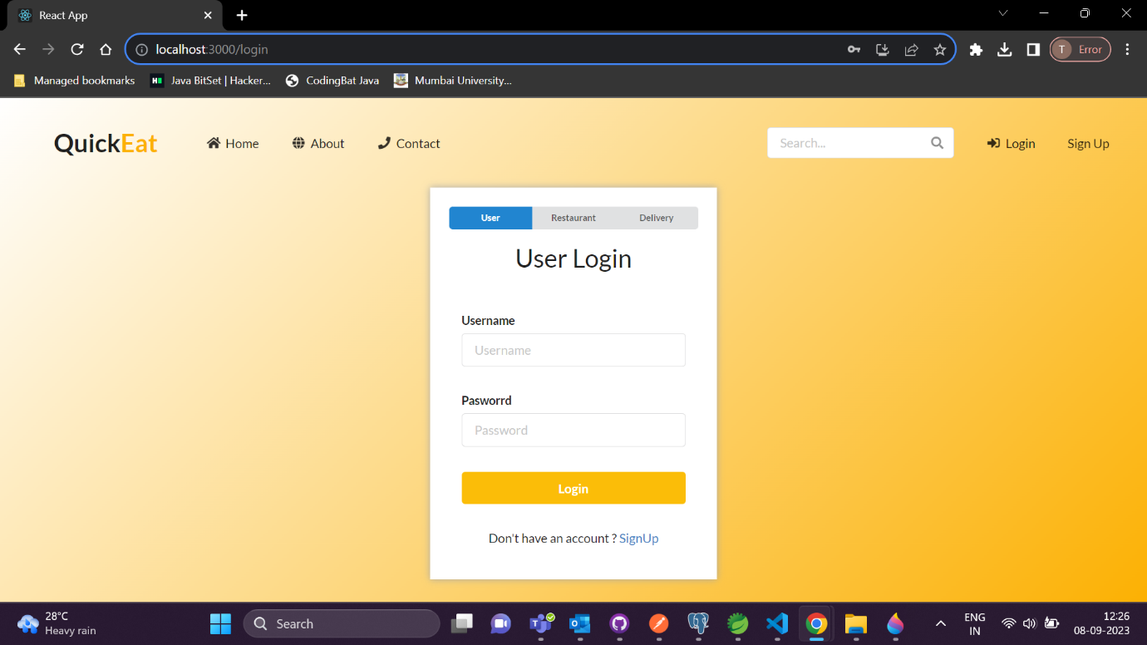

**User :**

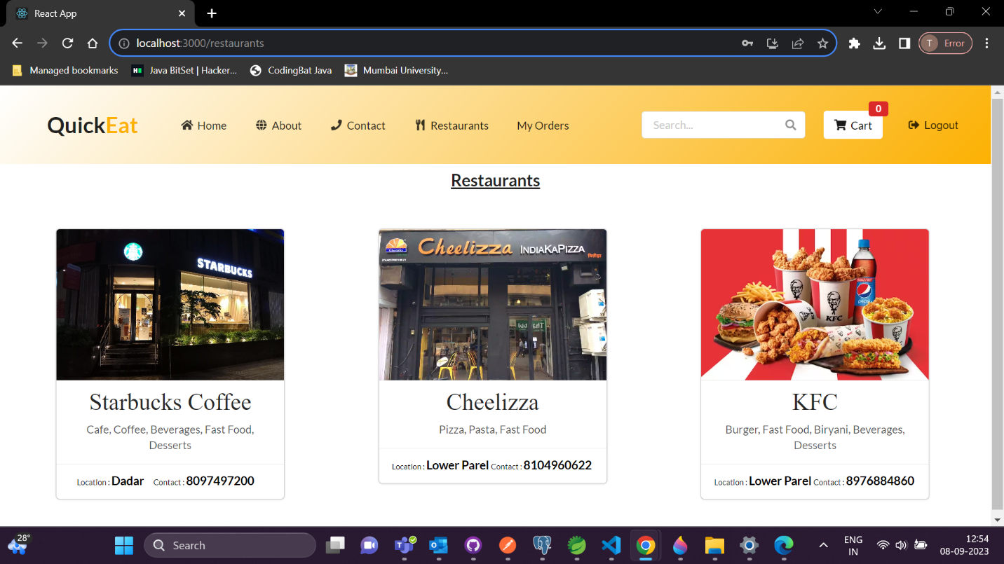

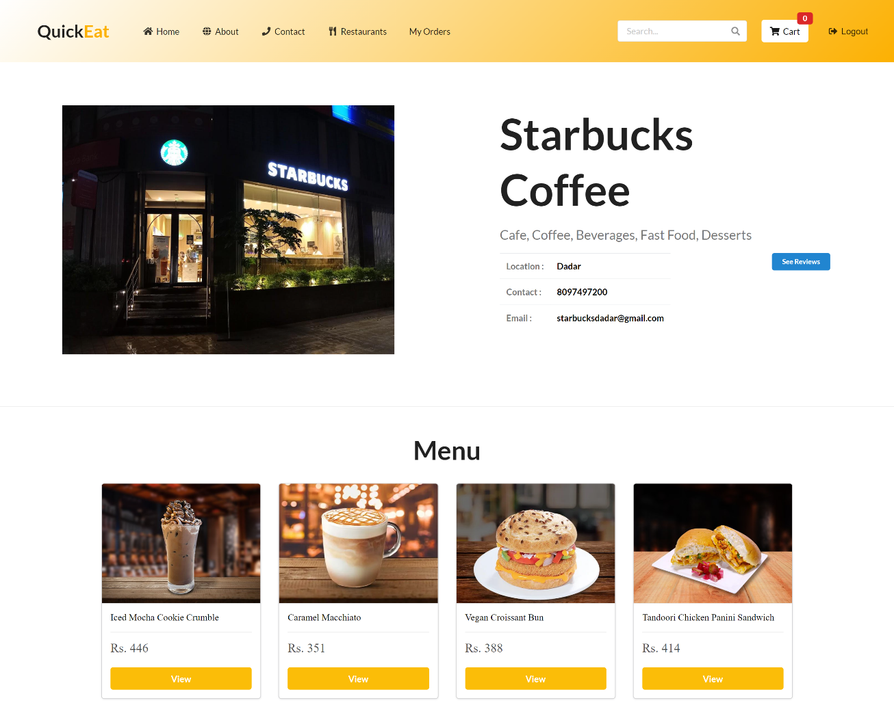

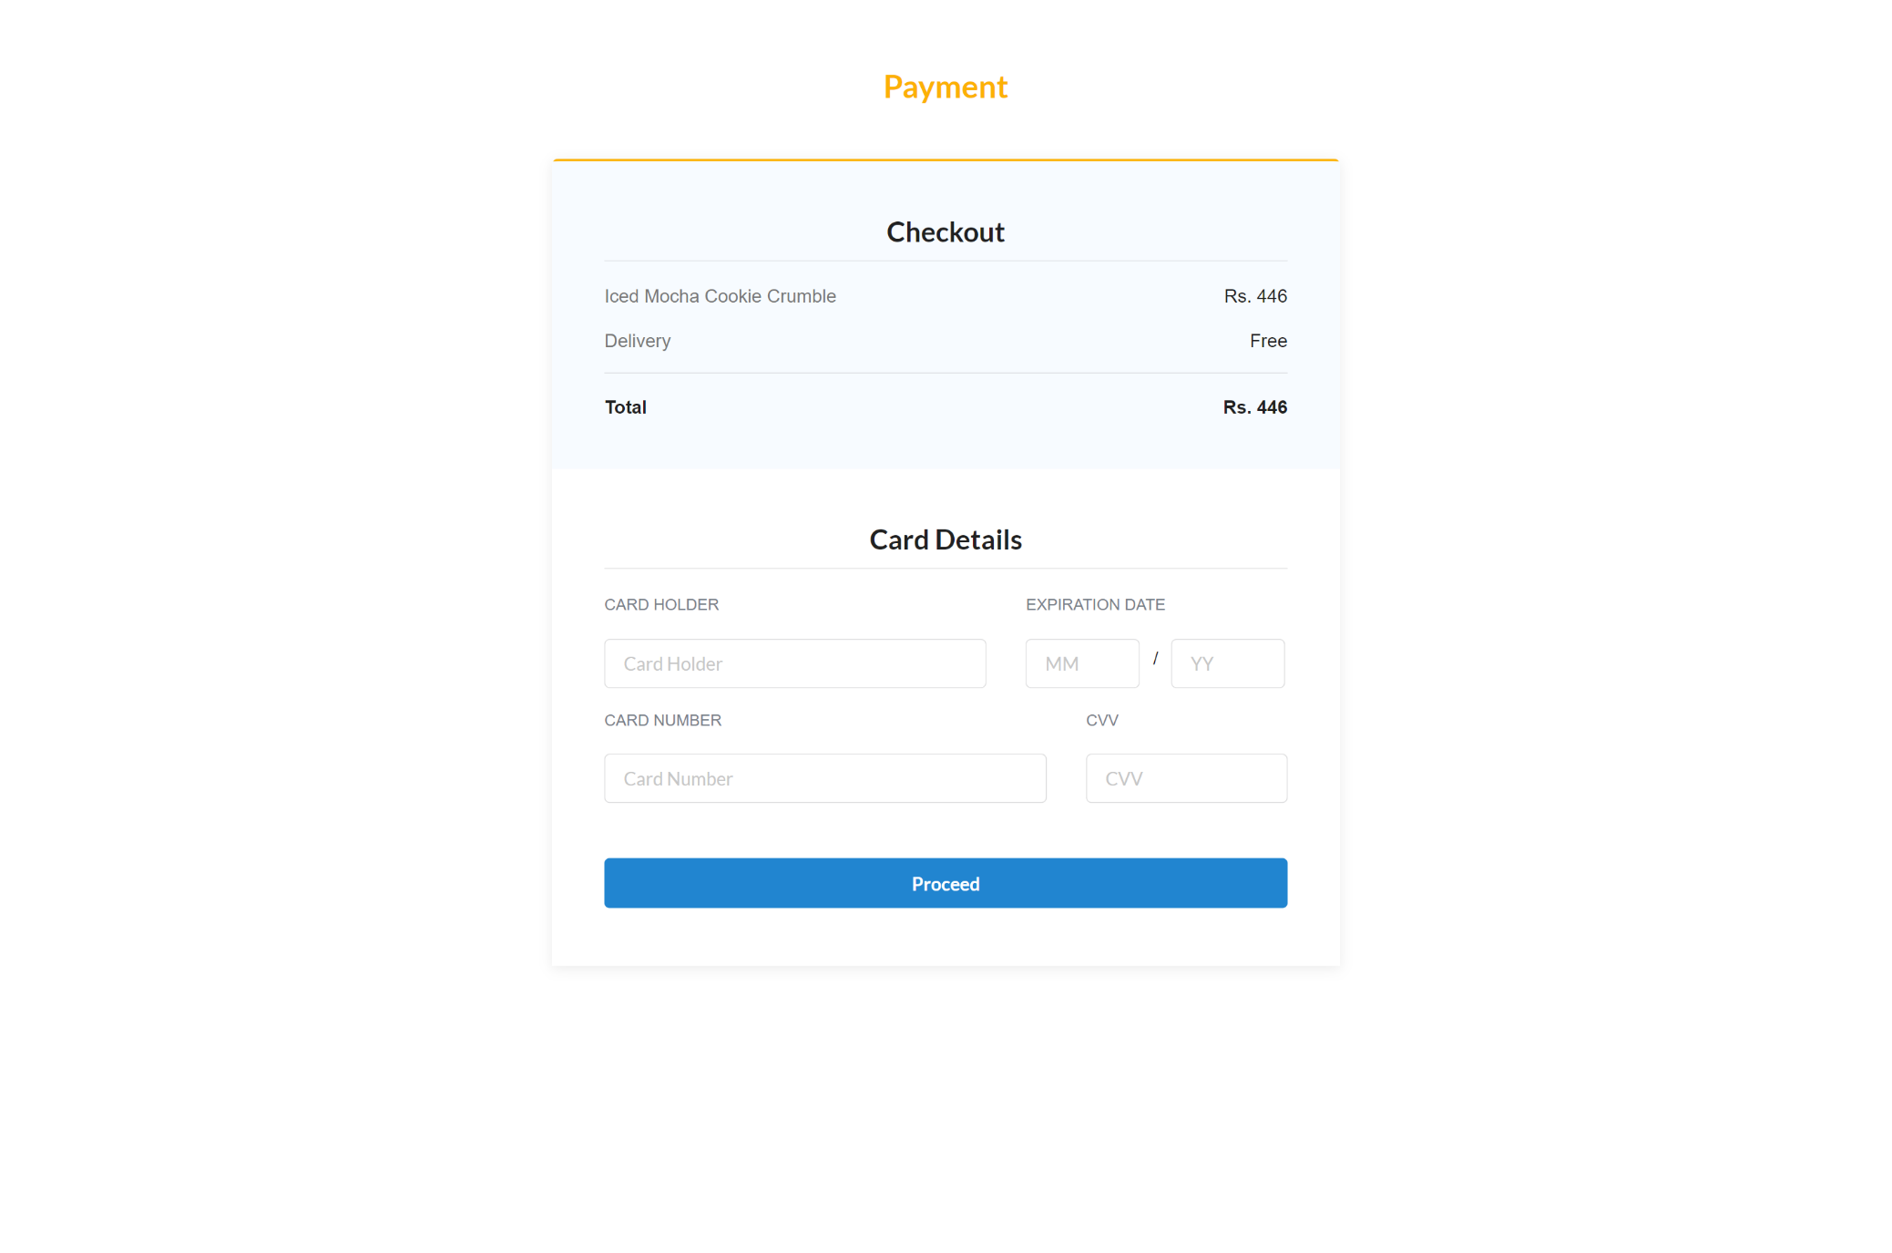

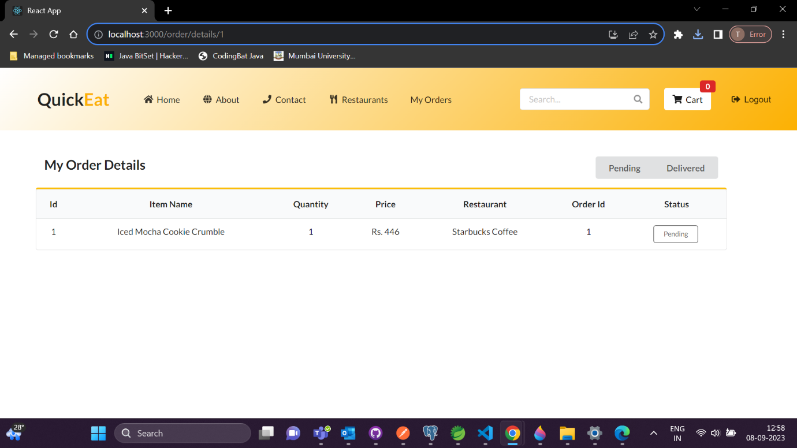

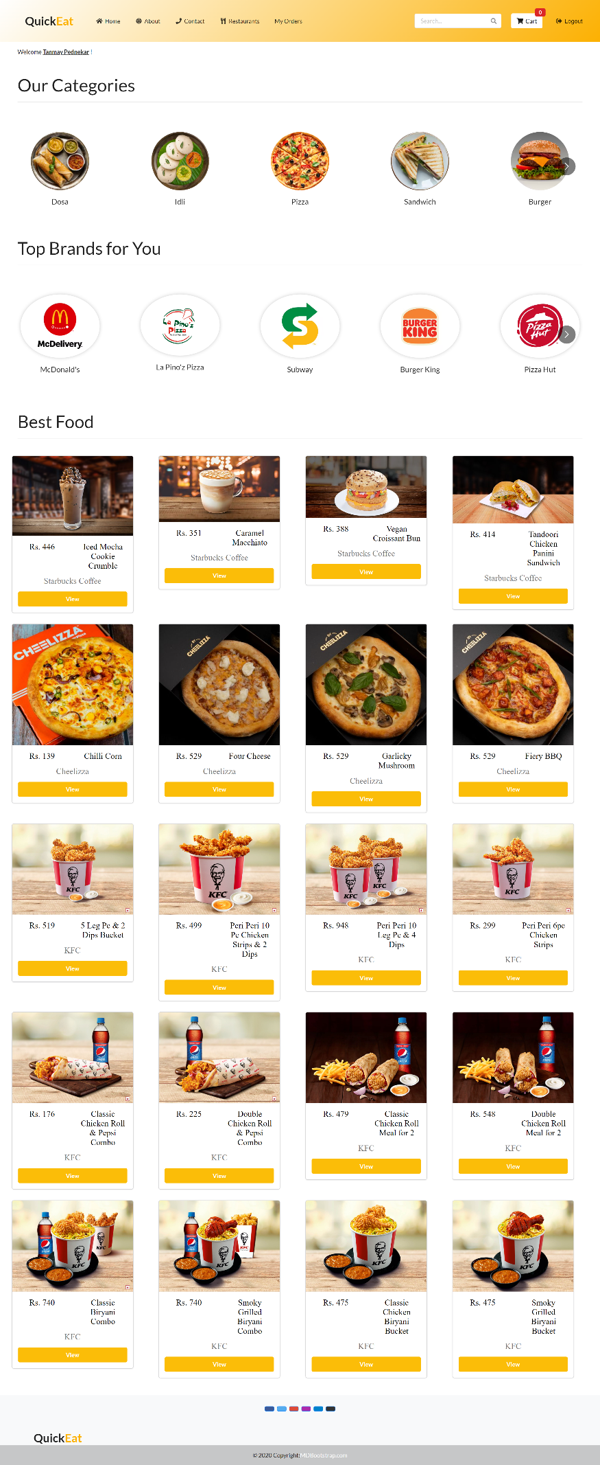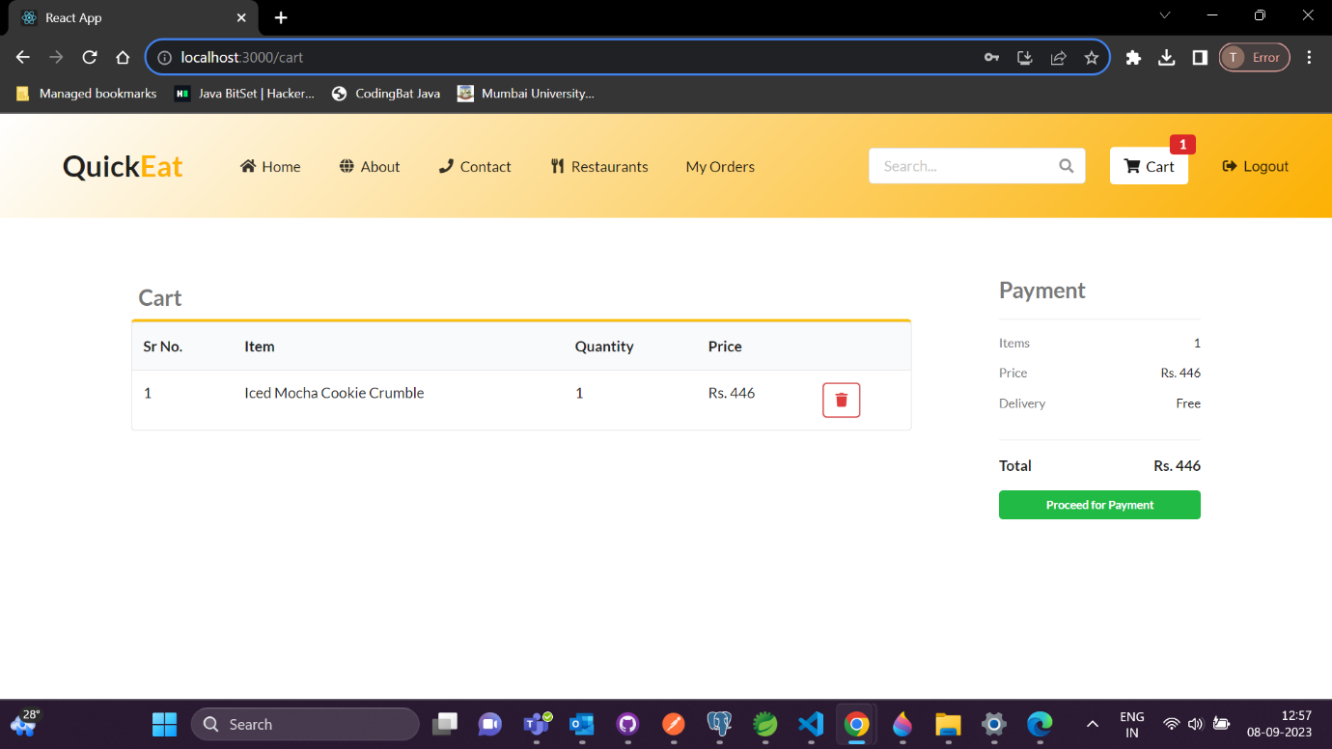

**Restaurant :**

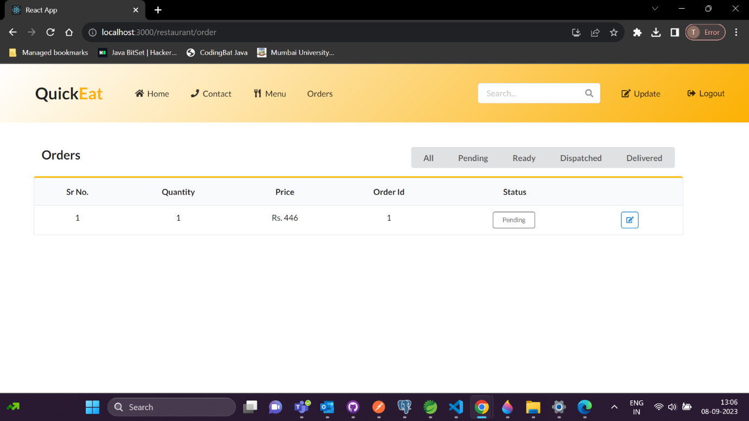

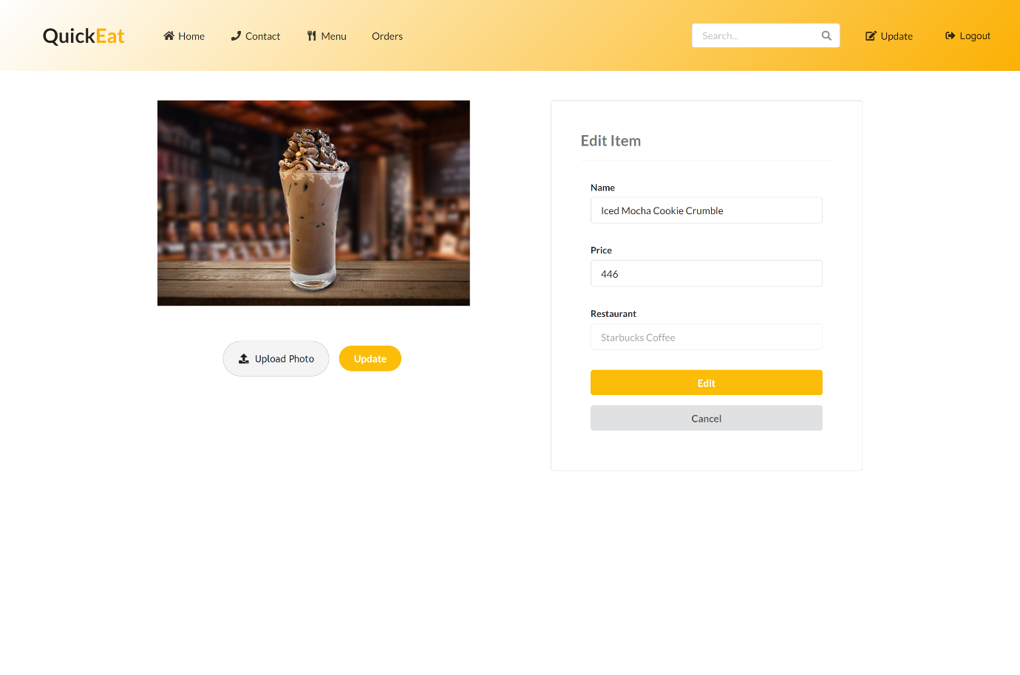

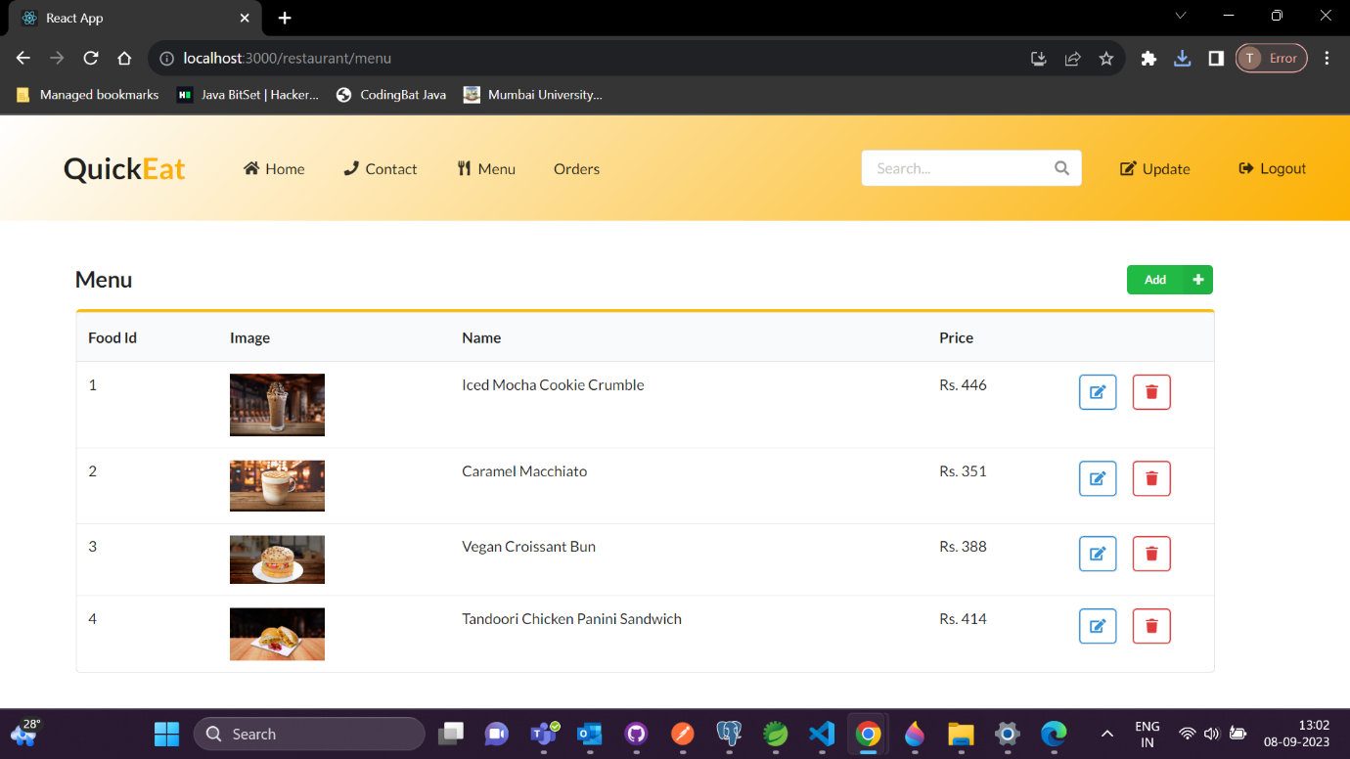

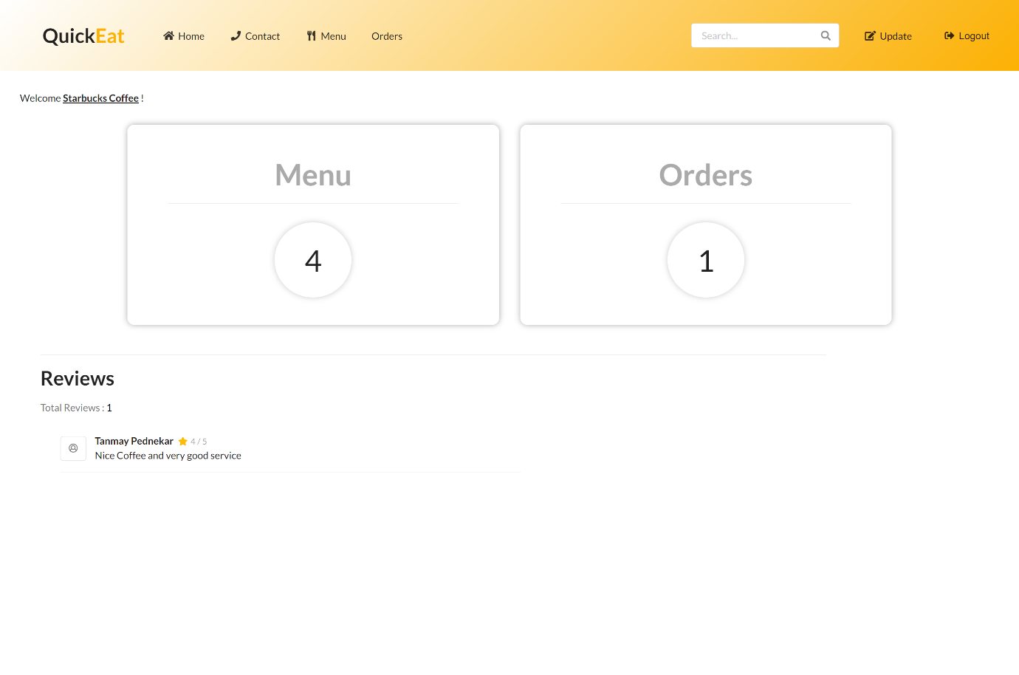

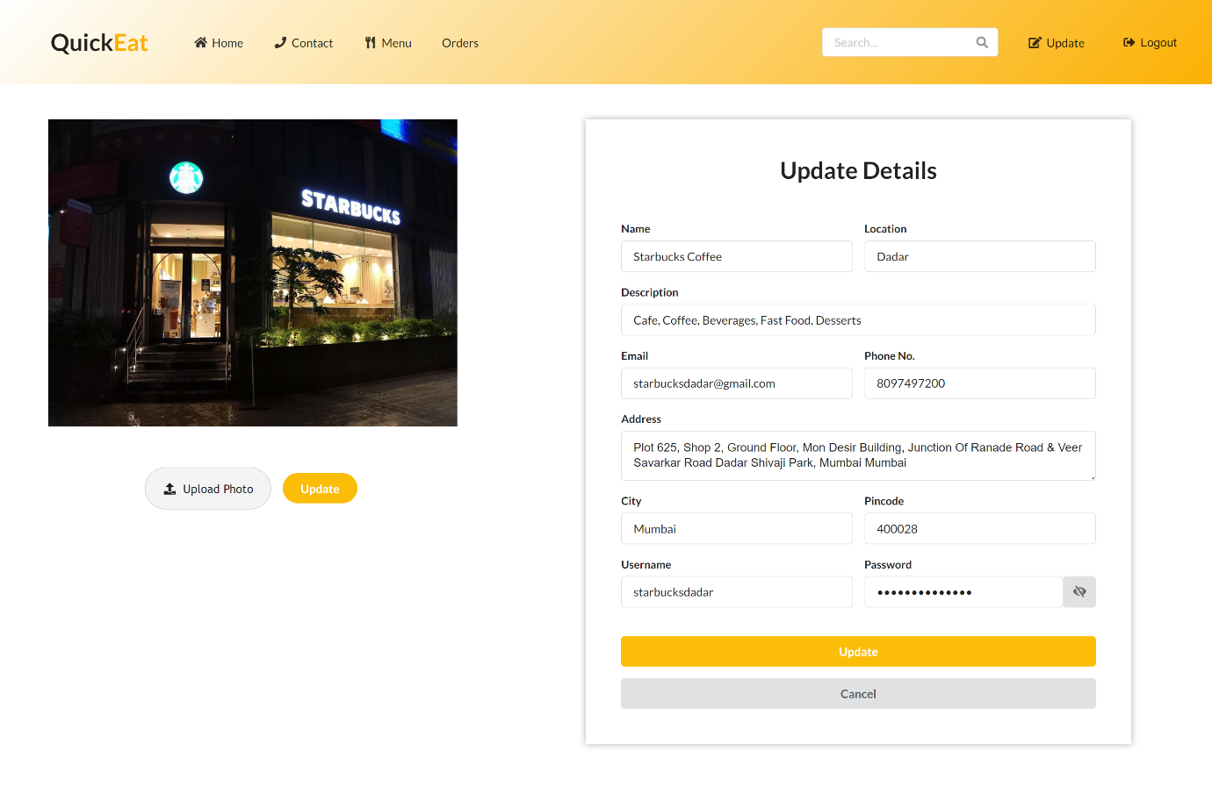

**Delivery Boy :**

